Lab 8
Objectives
The objective of this lab is to implement programs that perform statistical estimation techniques, specifically point estimation and interval estimation. For point estimation, the goal is to compute the sample mean from a given dataset and evaluate its bias relative to a known population mean. This helps in understanding how accurately the sample represents the population. In the case of interval estimation, the objective is to calculate the confidence interval for the sample mean using statistical formulas, which provides a range within which the true population mean is likely to lie with a specified level of confidence (e.g., 95%). These estimations are fundamental in inferential statistics and support decision-making based on sampled data.

Q.1. Write a program to determine point estimation and its bias for a sample of data with a given population mean.
Source Code:
#include <stdio.h>
#include <stdlib.h>
double calculateMean(double *data, int n) {
double sum = 0.0;
int i;
for (i = 0; i < n; i++) {
sum += data[i];
}
return sum / n;
}
int main() {
int n;
double populationMean;
printf("Enter the number of data points (sample size): ");
scanf("%d", &n);
double *data = (double *)malloc(n * sizeof(double));
if (data == NULL) {
printf("Memory allocation failed!\n");
return 1;
}
printf("Enter %d data values:\n", n);
int i;
for (i = 0; i < n; i++) {
scanf("%lf", &data[i]);
}
printf("Enter the population mean: ");
scanf("%lf", &populationMean);
double sampleMean = calculateMean(data, n);
double bias = sampleMean - populationMean;
printf("\nResults:\n");
printf("Sample Mean (Point Estimate): %.2lf\n", sampleMean);
printf("Bias: %.2lf\n", bias);
free(data);
return 0;
}
Output:
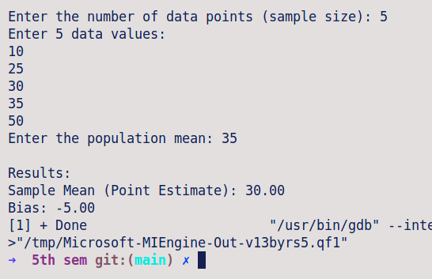

Q.2. Write a program to determine interval/ confidence interval estimation for a sample of data with a given population mean.
Source Code:
#include <stdio.h>
#include <stdlib.h>
#include <math.h>
double calculateMean(double *data, int n) {
double sum = 0.0;
int i;
for (i = 0; i < n; i++) {
sum += data[i];
}
return sum / n;
}
double calculateStdDev(double *data, int n, double mean) {
double sum = 0.0;
int i;
for (i = 0; i < n; i++) {
sum += pow(data[i] - mean, 2);
} return sqrt(sum / (n - 1));
}

int main() {
int n;
double z_score = 1.96;
printf("Enter the number of data points (sample size): ");
scanf("%d", &n);
double *data = (double *)malloc(n * sizeof(double));
if (data == NULL) {
printf("Memory allocation failed!\n");
return 1;
}
printf("Enter %d data values:\n", n);
int i;
for (i = 0; i < n; i++) {
scanf("%lf", &data[i]);
}
double sampleMean = calculateMean(data, n);
double sampleStdDev = calculateStdDev(data, n, sampleMean);
double marginOfError = z_score * (sampleStdDev / sqrt(n));
double lowerBound = sampleMean - marginOfError;
double upperBound = sampleMean + marginOfError;
printf("\nResults:\n");
printf("Sample Mean: %.2lf\n", sampleMean);
printf("Sample Standard Deviation: %.2lf\n", sampleStdDev);
printf("95%% Confidence Interval: [%.2lf, %.2lf]\n", lowerBound, upperBound);
free(data);
return 0;
}
Output:
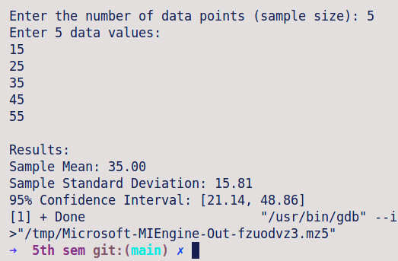
Conclusion
In conclusion, the lab successfully demonstrated the application of point and interval estimation methods using sample data and a known population mean. Through point estimation, we observed how the sample mean serves as an estimator for the population mean and how bias can be measured to assess its accuracy. Interval estimation further provided insight into the reliability of this estimate by constructing a confidence interval, offering a probabilistic range in which the true population mean is expected to lie. These techniques are essential tools in statistical inference, enabling informed predictions and analysis when working with partial data from a larger population.

